**Optimizing CVE Severity Prediction: A Hybrid TF-IDF and DistilBERT Approach with Attention-Based Deep Learning**

*A report submitted in partial fulfilment for the Assignment of*

*22AIE311 Software Engineering (Project Based)*

By

**R Kabin Dev: AIE22015 P Gagan Devesh: AIE22027 K Balavignesh Reddy: AIE22016**



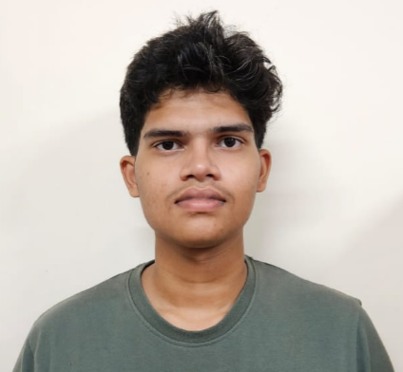

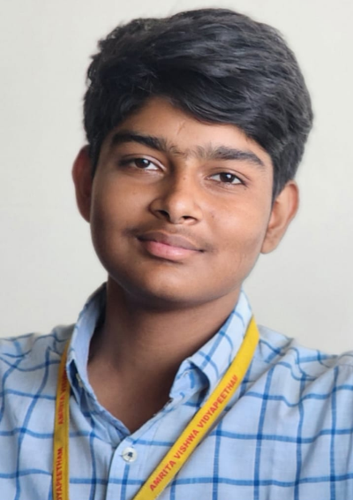

Under the Supervision of

**Dr. Chandan Kumar**

Assistant Professor (Sl. Gr.)



School of Computing

Amrita Vishwa Vidyapeetham, Amaravati Campus

Andhra Pradesh, 522503, India

2025